Android App Development Evolution with Kotlin

Introduction: Android is one of the most popular mobile operating systems in the world. It was developed by Google and is used by millions of people on smartphones, tablets, smart TVs, and wearable devices. Android development has evolved significantly over the years. Earlier, developers mainly used Java and basic tools, but modern Android development now includes advanced technologies such as Kotlin, Android Studio, Jetpack libraries, and Jetpack Compose.

This assignment discusses the evolution of Android development and explains the importance of Kotlin in modern Android application development.

History of Android Development: Android Inc. was founded in 2003 and later acquired by Google in 2005. In 2008, the first Android smartphone was released with Android 1.0. Initially, Android applications were developed using Java programming language and Eclipse IDE.
Developers used XML files to design user interfaces and Java classes to control application logic. Over time, Android development tools and programming methods improved to make application development faster, easier, and more efficient.

Early Android Development: In the early stages, Android development included:
- Java programming language
- Eclipse IDE
- Android Development Tools (ADT)
- XML layouts

Applications were created using components such as:
- Activities
- Services
- Broadcast Receivers
- Content Providers
Although Java was powerful, it required a large amount of code, making development slower and more complex.

Evolution of Android Versions: Android introduced many versions with new features and improvements.
Android Version | Major Features
Cupcake | Virtual Keyboard
Gingerbread | Improved UI
Ice Cream Sandwich | Better Design
KitKat | Performance Optimization
Lollipop | Material Design
Marshmallow | Runtime permission
Nougat | Split Screen Mode
Pie | Gesture navigation
Android 10 | Dark mode
Android 12 | Material You design

Each new version improved security, performance, and user experience.

Android Studio: Google introduced Android Studio in 2013 as the official IDE for Android development.
Features of Android Studio:
- Smart code editor
- Emulator support
- Gradle build system
- Layout editor
- Debugging tools
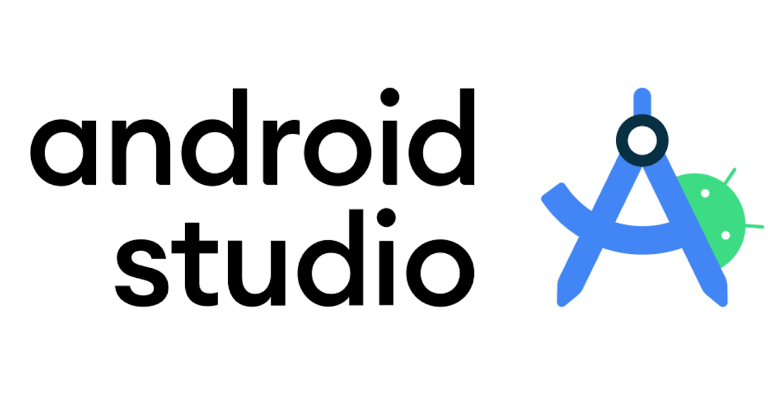
Android Studio replaced Eclipse and became the standard tool for Android app development.
Introduction to Kotlin: Kotlin is a modern programming language developed by JetBrains. In 2017, Google officially announced Kotlin as a preferred language for android development.
Kotlin is fully compatible with Java and runs on JVM. It is a statically typed programming language.
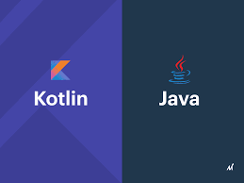

Advantages of Kotlin: Kotlin provides many advantages over java.
- Less Code: Kotlin requires less broiler plates.
- Null Safety: Kotlin reduces NullPointerException errors using null safety features.
- Coroutines: Kotlin supports coroutines for asynchronous programming.
- Better Readability: Kotlin code is cleaner and easier to understand compared to Java.

Modern Android Development: Modern Android development focuses on:
- Kotlin-first approach
- Jetpack libraries
- MVVM architecture
- Firebase integration
- Jetpack Compose
Developers now create applications faster with improved performance and better UI design.

Jetpack Compose: Jetpack Compose is a modern toolkit for building Android user interfaces using Kotlin.
Traditional Android UI used XML layouts, but Compose uses a declarative approach.
Advantages of Jetpack Compose:
- Faster UI development
- Less code
- Easier animations
- Better state management

Challenges in Android Development: Developers still face several challenges:
- Device fragmentation
- Different screen sizes
- Performance optimization
- Security management
- Frequent updates in technology

Future of Android Development: The future of Android development includes:
- Artificial Intelligence (AI)
- Machine Learning
- Foldable device support
- Cross-platform development
- Advanced security systems
Kotlin and Jetpack Compose are expected to become even more important in future Android applications.

Conclusion: Android development has evolved greatly from simple Java-based applications to modern Kotlin-powered applications. Earlier development methods were complex and required more code, while modern technologies such as Kotlin and Jetpack Compose have made Android development faster, safer, and more efficient.
Kotlin has become one of the most important technologies in Android development because of its simplicity, safety, and modern programming features. The continuous evolution of Android ensures better applications and improved user experiences for the future.

